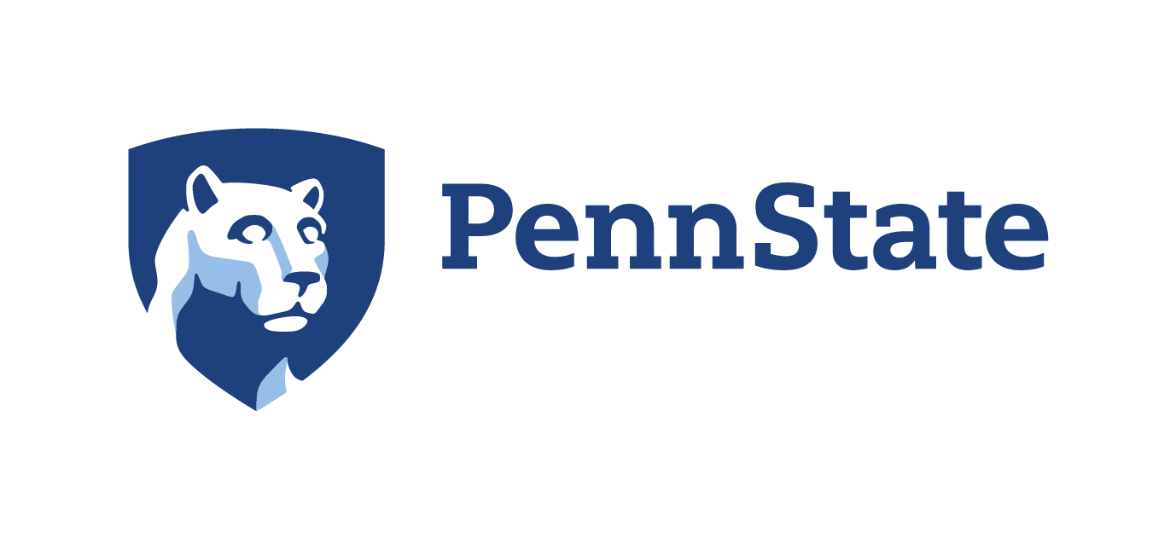

ACADEMIC LEADERSHIP FORUM

Open Forum
Return to Fall Instruction

Zoom
Wednesday, July 8, 2020
10:00 – 11:00 a.m.

10:00 – 10:05 a.m. Opening Remarks

10:05 – 10:55 a.m. Open Forum and Return to Fall Instruction
Nicholas P. Jones, Executive Vice President & Provost

Moderator: Kathleen J. Bieschke, Vice Provost for Faculty Affairs

10:55 – 11:00 a.m. Closing Remarks

